EASO publishes a COI report: Iraq – Security situation and information on civilians killed in Iraq in 2017-2018 (by Iraq Body Count)

* 14TH MARCH 2019

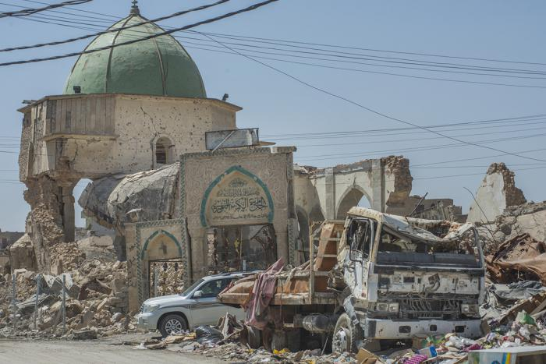

***Today, the European Asylum Support Office (EASO) published a Country of Origin Information (COI) Report titled Iraq: Security situation. This report is part of a series of Iraq reports produced in 2018-2019. These reports cover actors of protection, internal mobility, key socio-economic indicators, and targeting of individuals. The reports provide information relevant for international protection status determination for Iraqi asylum seekers, and will be used in the development of a country guidance note on Iraq.***

Despite a decrease in asylum applications lodged by Iraqi nationals in EU+ countries in 2018, **Iraq**was the **third most common country of origin** with **more than 42,000 applicants**. In January 2019, Iraqi nationals remained the third largest group of applicants in EU+ countries after Syrian and Afghan nationals. At the end of January 2019, about **26,000 cases**awaited a **first-instance decision**.

The report [EASO COI Report: Iraq – Security situation](https://coi.easo.europa.eu/administration/easo/PLib/Iraq_security_situation.pdf) provides a general overview of the security situation in Iraq, covering the following topics: a general background of recent conflicts in Iraq; the current political situation; information on the main armed actors and their territorial presence and role; an overview of recent security trends; the impact of violence on the civilian population and on the state ability to secure law and order.

The second part of the report provides a governorate-level description of the security situation. Each governorate chapter includes a map, a brief description of the governorate, background conflict dynamics and armed actors present in the area, followed by a description of security trends in 2018, and the impact of violence on the population.

The report was drafted by Country of Origin Information (COI) specialists on Iraq from Belgium, France and Sweden, together with the EASO COI sector, in accordance with the [EASO COI Report Methodology](https://coi.easo.europa.eu/administration/easo/PLib/EASO_COI_Report_Methodology.pdf), and was reviewed by COI experts from Norway (Landinfo), Austria and Greece. Additionally, an external expert review was carried out by ACCORD, and also by Dr. Fanar Haddad, a Senior Research Fellow at the Middle East Institute, National University of Singapore who specialises in sectarian issues and politics in Iraq.

In addition to the security situation report, EASO published a country of origin information document produced by Iraq Body Count (IBC), which provides data and trends with regard to civilian deaths during the conflict in 2017-2018: [Iraq Body Count Data and Analysis on Civilians Killed in Iraq, 2012, 2017-2018](https://coi.easo.europa.eu/administration/easo/PLib/Iraq_IBC_Civilian_Deaths.pdf).

Additional information to complement this report can be found in the following EASO reports:

* [EASO COI Report: Iraq – Actors of Protection](https://coi.easo.europa.eu/administration/easo/PLib/Iraq_Actors_of_Protection_2018.pdf)
* [EASO COI Report: Iraq – Key socio-economic indicators](https://coi.easo.europa.eu/administration/easo/PLib/Iraq_key_socio-economic_indicators.pdf)
* [EASO COI Report: Iraq – Internal mobility](https://coi.easo.europa.eu/administration/easo/PLib/Iraq-Internal_Mobility.pdf)
* [EASO COI report, Iraq – Targeting of individuals](https://coi.easo.europa.eu/administration/easo/PLib/Iraq_targeting_of_individuals.pdf)

You can download the report at: <https://coi.easo.europa.eu/administration/easo/PLib/Iraq_security_situation.pdf>.